Occupancy Counting based on Infrared Array

and Time-of-Flight Doorway Sensor

ESE534 Course Project

Zhangjie Chen, Haichao Wang, Zhao Ma

1. Introduction

Occupancy estimation is crucial and has a wide range of applications. People counting in a specific area is a practical and common problem which has been widely researched. But how to count people with cheapest sensor and highest accuracy but without the hazardous of privacy invasion problem? The answer is using less intrusive and low-cost sensors.

The common approaches are listed as below:

**Break-Beam sensors**

It cannot detect situation when multiple people move simultaneously.

**Camera:**

High accuracy, privacy invasion.

Accuracy largely decreases in low illumination situations.

**PIR sensor array:**

It’s a reliable solution for occupancy detection. Currently this approach cannot count the number of people especially when multiple people moving together.

**Depth camera:**

Little privacy invasion. High accuracy. High cost.

**Ultrasound sensor:**

Slow, sensitive to material, not pet friendly and may need training.

**Ambient sensor: Ex. CO2 sensor**

Only capable of rough estimation, cannot do accurate counting.

In summary, the main challenges for occupant counting are listed,

(1) Privacy invasion is one of the major challenges that largely limits the application of camera-based solutions.

(2) Some approaches calculate the occupants number within its FOV. This is not reliable when the room is crowded since occupants could be overlapped and occluded. Also, for large rooms multiple sensors are required.

(3) Other approaches based on doorway sensors detect the number of occupants in and out, a main challenge is in the situations that multiple people simultaneously cross a door.

Our approach is both low-cost and computationally complex, but high in accuracy and robustness. The following sections are organized in sequence likes this: The section 2 is system design which provided detailed information about the system hardware and platform. The section 3 is experiment which describe the different situations we made for testing the system performance. The section 4 is about the analysis of data and process algorithm that we used for occupancy counting. The section 5 is summary and future work, and the last part is reference.

2. System design

2.1 Systematic design

This system aims to provide reliable occupant counting based on single sensor node. This problem will be addressed by a sensor array installed on top of the doorway. This design consists one IR array sensor and several TOF distance sensors. The VL53l0x is selected as the TOF sensor and Grid-EYE as the IR array sensor.

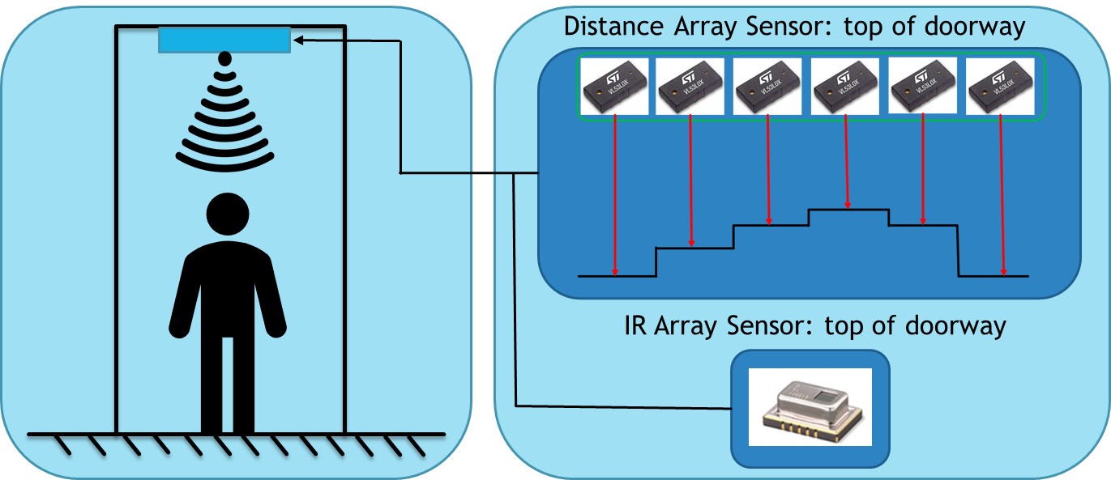

Figure Systematic design

This approach leads to the following potential advantages:

(1) Low cost (total sensor cost：< $ 30)

(2) The sensor is installed on top of the doorway, thus largely avoid occupant overlapping and occlusion

(3) The Vl53l0x sensor is faster than ultrasound sensor and it can generate more reliable and accurate measurement

(4) low pixel infrared array sensor can identify multiple occupants in the FOV

(5) This design has the potential to reflect user biometrics and identify between limited human subjects.

2.2 Vl53l0x Time-of-Flight sensor

The VL53L0X is a new generation Time-of-Flight (ToF) laser-ranging module housed in the smallest package on the market today, providing accurate distance measurement whatever the target reflectance unlike conventional technologies. It can measure absolute distances up to 2m, setting a new benchmark in ranging performance levels, opening the door to various new applications. Some of the key advantages are included.

(1) It is a fully integrated miniature module with advanced embedded micro controller. It enables fast, accurate distance ranging up to 2m and has a tiny size of 4.4 x 2.4 x 1.0mm. In addition, reported range is independent of the target reflectance and also it can operate in high infrared ambient light levels

(2) It’s a Class 1 laser device which guarantee can eye safe. It is easy to be integrated since it requires no additional optics and has I2C interface for device control and data transfer, Xshutdown (Reset), interrupt GPIO and Programmable I2C address

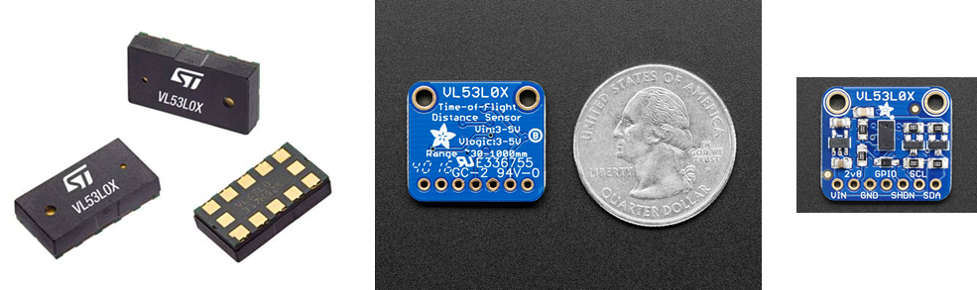

Figure 1 Vl53l0x ToF sensor

2.3 Grid-EYE sensor

Grid-EYE is an 8x8 (64) pixel infrared array sensor manufactured by Panasonic.inc. This sensor offers digital output (I2C) for thermal presence, direction, and temperature values. The built-in lens includes a 60-degree viewing angle. Grid-EYE features compact SMD design using MEMS thermopile technology. The applications for this sensor can include: digital signage, security, lighting control, kiosk/ATM, medical imaging, automatic doors, thermal mapping, people counting, robotics.

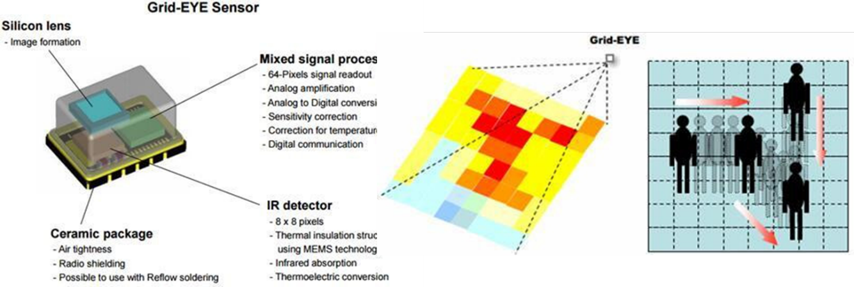

Figure 2 Basic property of Grid-EYE sensor

2.4 Prototype development

Four Vl53l0x sensors and one Grid-EYE sensor are integrated together. The whole system is based on an Arduino control board and all the support frame was customized and manufactured by 3D Printer. Data are sent to computer through a Bluetooth module at 10Hz. The figure 3 shows the 3D model and the snapshot of the prototype.

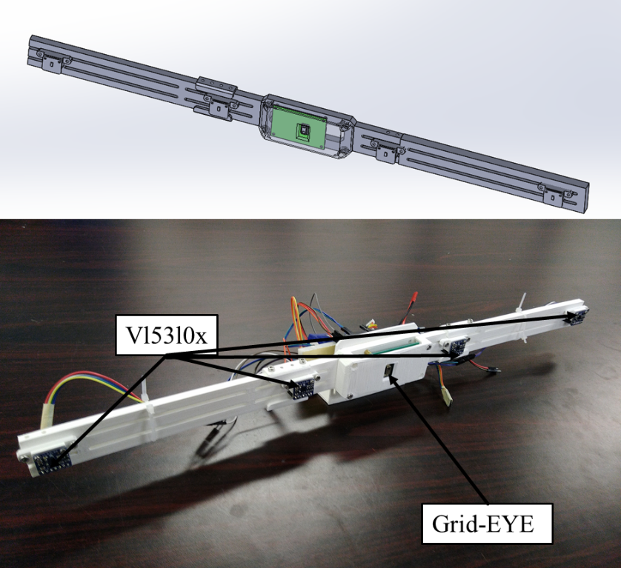

Figure 3 the prototype for user counting

3. Experiment

The prototype is set on top of a door frame. Three users are included in the experiment to conduct different situations of passing a doorway.

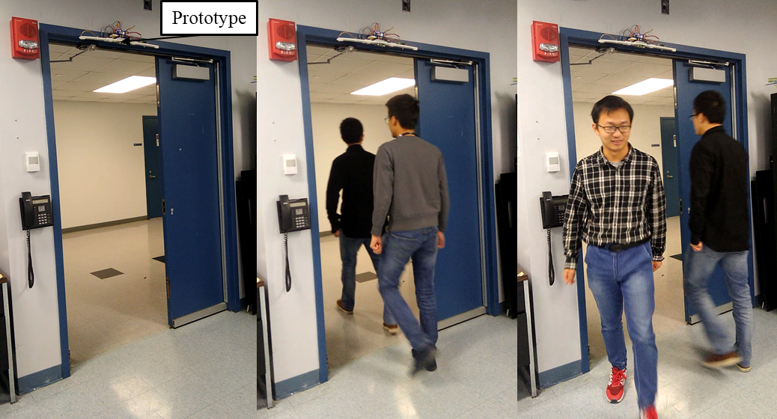

Figure 4 Snapshot of the experiment

Three people walk closely to each other or walk in the opposite direction pass through the door in a normal walking speed. This process largely reconstructs the situation which will happen in the real world.

We did the same test under two situations: door-closed and door-opened. While the door is opening, the data from Grid-EYE and IR sensor is pretty stable. But when we close the door and do the same test, there are some disturbances showed in the data. So our test was based on open-door environment, and in the future we will modify the algorithm for close-door situation.

After data collection, we use Matlab to filter and process the data.

4. Algorithm and result analysis

4.1 Counting based on Vl53l0x sensor

By counting the valley of Vl53l0x sensor data, the number of people that pass through a door way can be easily found out. While based on current sensor setup, the direction of the user may not be able to judge.

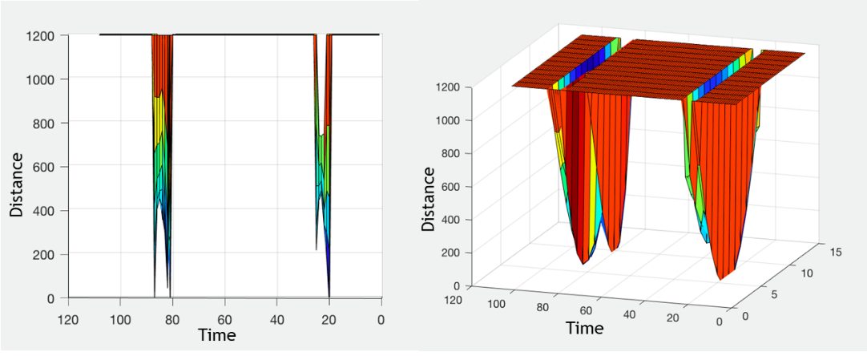

Figure 5 ToF sensor experiment result

4.2 Counting based on Grid-EYE sensor

For better accuracy, raw data first go through Interpolation and then background subtraction and Gaussian filter to get a smooth and robust image. At the end, we set a threshold according to experiment and then get a final threshold Image. And then the center of hotspots can be calculated.

By connecting the hotspot center coordinates, a trajectory of the user can be identified.

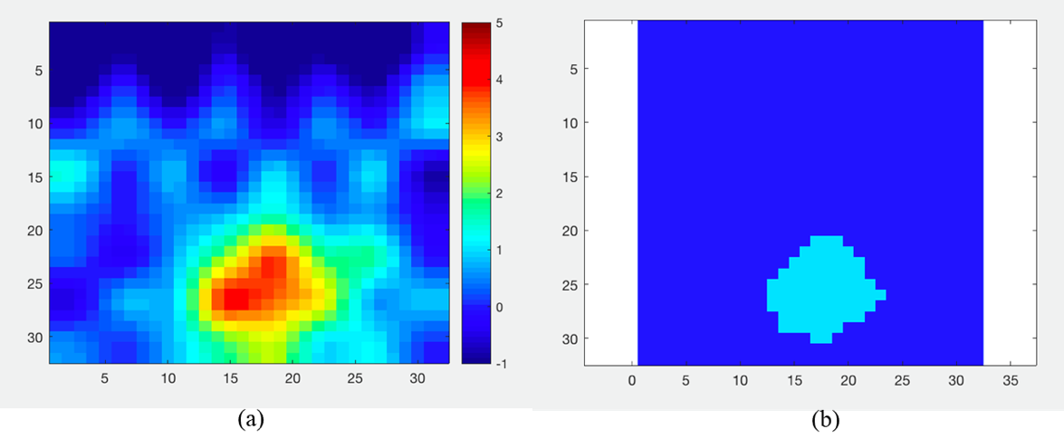

Figure 6 (a) Interpolated image after background subtraction and Gaussian filter

(b) Grid-EYE sensor image after binarization

To match the hotspots centers between two continuous frames, the distances between all the hotspots coordinates from two continuous frames are calculated. And then the matching process is based on the minimum distance. This method is simple and effective, while it doess have limitations includes such as same distances can be found since the distances are calculated based on a 32x32 thermal image.

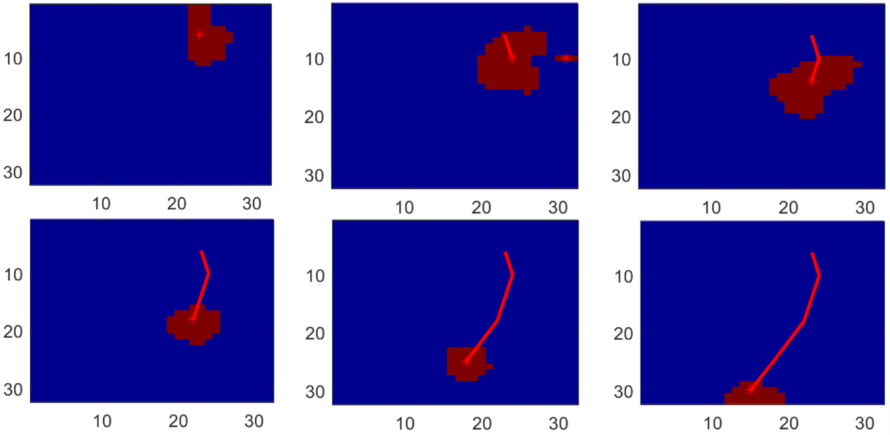

Figure 7 Snapshot of detecting a single user

4.3 Counting based on sensor fusion

Not much work has been done on combining the data from both sensors. We can know whether someone is passing the door with perfect certainty using the data from Vl53l0x sensor. If there are some unusual data showed on Grid-EYE sensor, using this feature, we can simply raise the threshold dynamically. After finding the centroid of threshold image, we can easily count people and recognize their moving direction by wiring each centroid between two consecutive frames to a spline

5. Summary and future work

Summary:

1. A sensor fusion doorway sensor prototype for occupant counting is developed

2. Counting experiment based on single and multiple user are performed

3. Simple algorithms have been applied to Grid-EYE sensor and Vl53l0x sensor to perform user counting

Future work can include:

1. Advanced sensor fusion method between Grid-EYE and Vl53l0x

2. More complicated experiments

3. Sensor fusion between several Vl53l0x sensors

**References**

[1] Timothy W. Hnat, Erin Griffiths, Ray Dawson, and Kamin Whitehouse. 2012. Doorjamb: unobtrusive room-level tracking of people in homes using doorway sensors. In Proceedings of the 10th ACM Conference on Embedded Network Sensor Systems (SenSys '12). ACM, New York, NY, USA, 309-322. DOI=http://dx.doi.org/10.1145/2426656.2426687

[2] G. Mokhtari, Q. Zhang, G. Nourbakhsh, S. Ball and M. Karunanithi, "BLUESOUND: A New Resident Identification Sensor—Using Ultrasound Array and BLE Technology for Smart Home Platform," in IEEE Sensors Journal, vol. 17, no. 5, pp. 1503-1512, March1, 1 2017.

[3] Vijay Srinivasan, John Stankovic, and Kamin Whitehouse. 2010. Using height sensors for biometric identification in multi-resident homes. In Proceedings of the 8th international conference on Pervasive Computing (Pervasive'10), Patrik Floréen, Antonio Krüger, and Mirjana Spasojevic (Eds.). Springer-Verlag, Berlin, Heidelberg, 337-354.

[4] Panasonic Corporation (2012, August). Infrared Array Sensor Grid-EYE (AMG88). Retrieved May 2013, from

http://pewa.panasonic.com/assets/pcsd/catalog/grid-eye-catalog.pdf

[5] S. Munir et al., "Real-Time Fine Grained Occupancy Estimation Using Depth Sensors on ARM Embedded Platforms," 2017 IEEE Real-Time and Embedded Technology and Applications Symposium (RTAS), Pittsburgh, PA, 2017, pp. 295-306.

[6] “Measuring People-Flow Through Doorways using Easy-to-Install IR Array Sensors” by Hessam Mohammadmoradi, Sirajum Munir, Omprakash Gnawali, and Charles Shelton. In Proceedings of the Thirteenth IEEE International Conference on Distributed Computing in Sensor Systems (DCOSS 2017), June 2017.